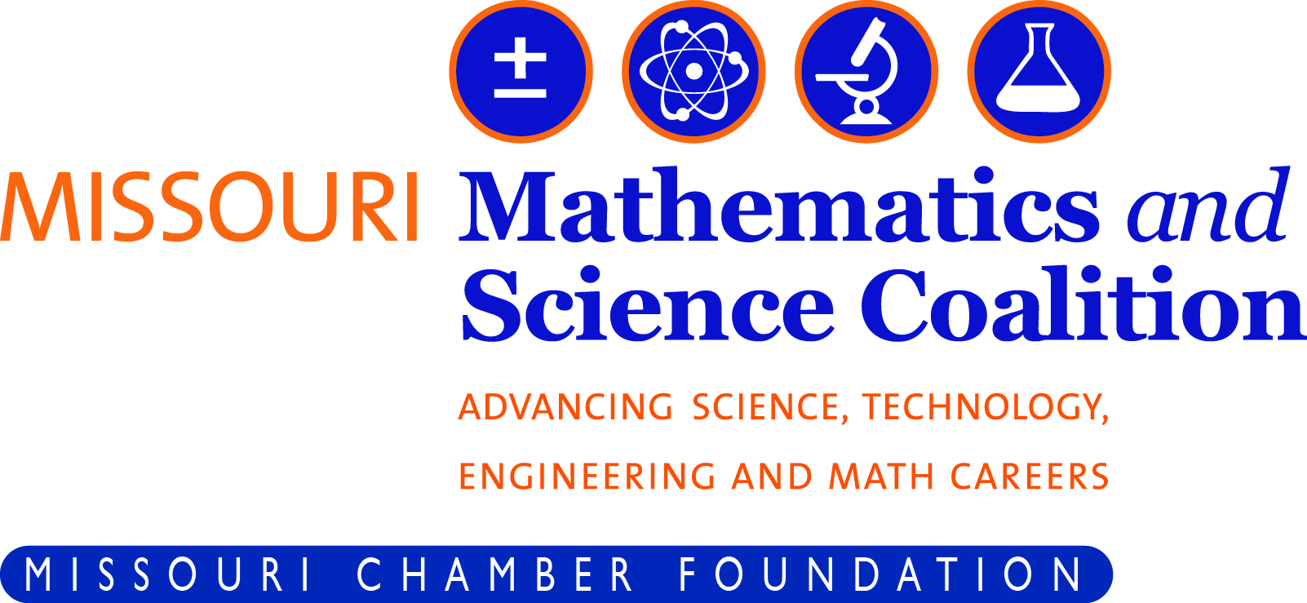
Carnegie STEM Leadership
Workshop Series

Did you embark on the Carnegie STEM Excellence Pathway? Or are you simply looking for insight into expanding STEM learning for your students?
Wednesday, January 31, 2018 – 8:30am to 2pm – Springfield, MO
Project Based Learning: Connecting the Classroom to the Real World?
Wednesday, February 28, 2018 – 8:30am to 2pm – Springfield, MO
Real World Connections: Creating Bonds between the
Community and the Classroom
Wednesday, March 28, 2018 – 8:30am to 2pm – Springfield, MO
Integrating Curriculum: Breaking Down Barriers Between Subject Area

The Missouri Mathematics and Science Coalition, the Southwest RPDC, Missouri State University are joining forces to expand upon the Carnegie STEM Excellence Pathway™ effort with a concentrated series of workshops aligned to the themes and criteria of the Carnegie STEM Excellence Pathway rubric. These workshops will drill down into various themes of the Carnegie STEM model. During each workshop we will address the topic or theme from both an administrator and educator perspective. All workshops will included a light breakfast, snacks and lunch. All materials being provided at no additional cost.
Who
- School and district administrators, principals, instructional coordinators, STEM educators, afterschool program coordinators and other leaders interested in bringing a stronger STEM (Science, Technology, Engineering and Mathematics) mindset and intention to the school and classroom.

What
- STEM Best practices for classrooms and schools, local resources and opportunities, sharing and peer to peer networking
- Strategies and success from STEM centric programs in the region and across the state
- In cooperation with the Carnegie Science Center (PA) and aligned to the Carnegie STEM Excellence Pathways model criteria
Cost: $99 per individual workshop session or
$249 by signing up for all three - Save $50
Registration
Register for the workshops at – www.mochamber.com under the events section or
RSVP directly to Megan Cantlon at 573-634-3511 or mcantlon@mochamber.com

STEM Progressing Workshop Session Details
Wednesday, January 31, 2018 – 8:30am to 2pm – Springfield, MO
Project Based Learning: Connecting the Classroom to the Real World?
Missouri State University – Darr Agriculture Center, 2401 South Kansas Expressway, Springfield, MO 65807
- Carnegie STEM Pathways Theme- Instructional Practices- Criteria 8,9,10
- Project based learning applied with real-world settings in mind, integrating STEM effectively
- Flexible scheduling that allows for STEM activities to be incorporate into the traditional classroom
- Making meaningful career connections in the process of learning
Wednesday, February 28, 2018 – 8:30am to 2pm – Springfield, MO
Real World Connections: Creating Bonds between the Community and the Classroom
Missouri State University – Darr Agriculture Center, 2401 South Kansas Expressway, Springfield, MO 65807
- Carnegie STEM Pathways Theme- Real World Connections – Criteria 16,17,18
- STEM is all around us, from the farm to the environment to the boardroom, but how do we convey this to students is the real challenge, or is it?
- We will focus on how to “connect the dots” from the community to the classroom from partnerships to curriculum
Wednesday, March 28, 2018 – 8:30am to 2pm – Springfield, MO
Integrating Curriculum: Breaking Down Barriers Between Subject Areas
Missouri State University – Darr Agriculture Center, 2401 South Kansas Expressway, Springfield, MO 65807
- Carnegie STEM Pathways Theme- Curriculum – Criteria 5,6,7
- Unify concepts across STEM subject areas and beyond
- We will focus on how to design units of instruction that engage students in relevant, meaningful activities that can be connected to real life
Powered By
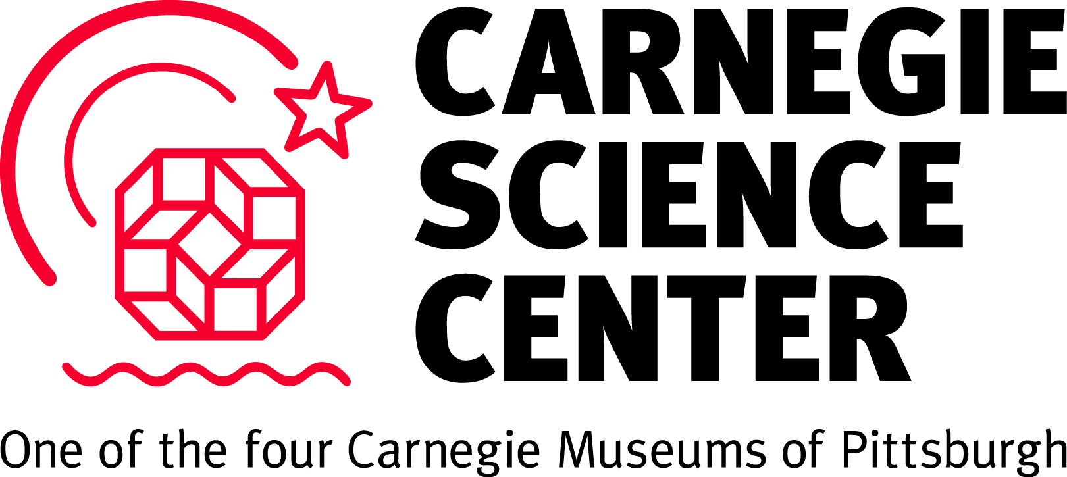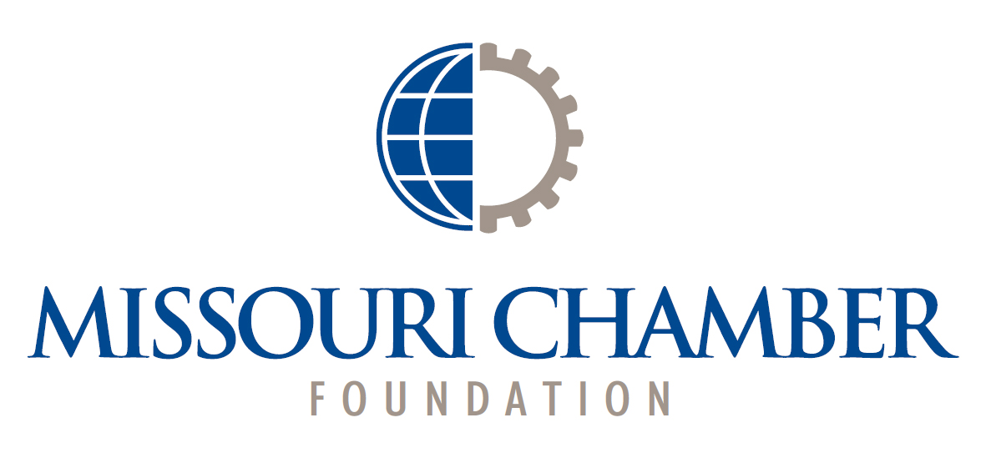
In Partnership with
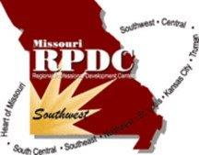 | 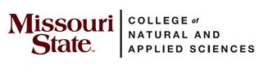

The Missouri Chamber Foundation is a registered, non-for-profit (501c3) that oversees the administration of the Missouri Mathematics and Science Coalition. US Federal Tax ID # 43-6051487

